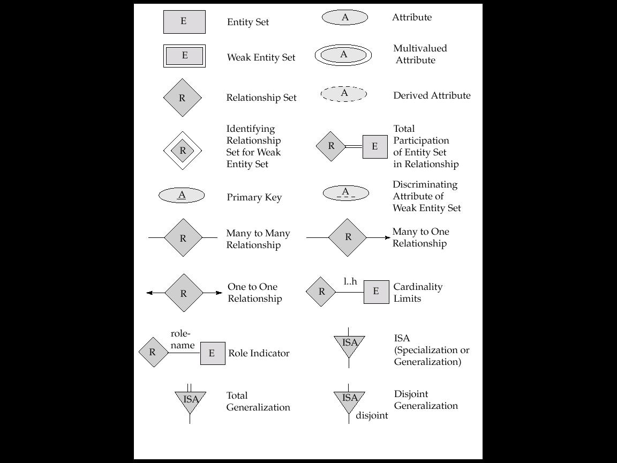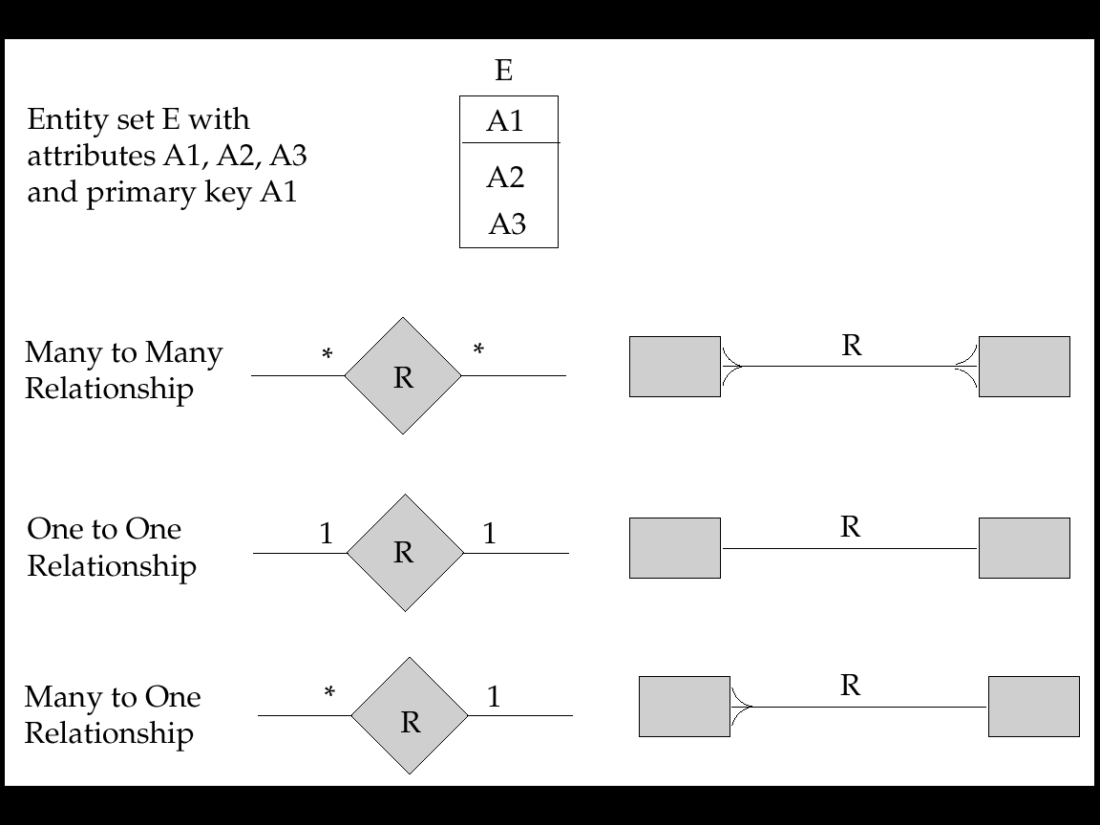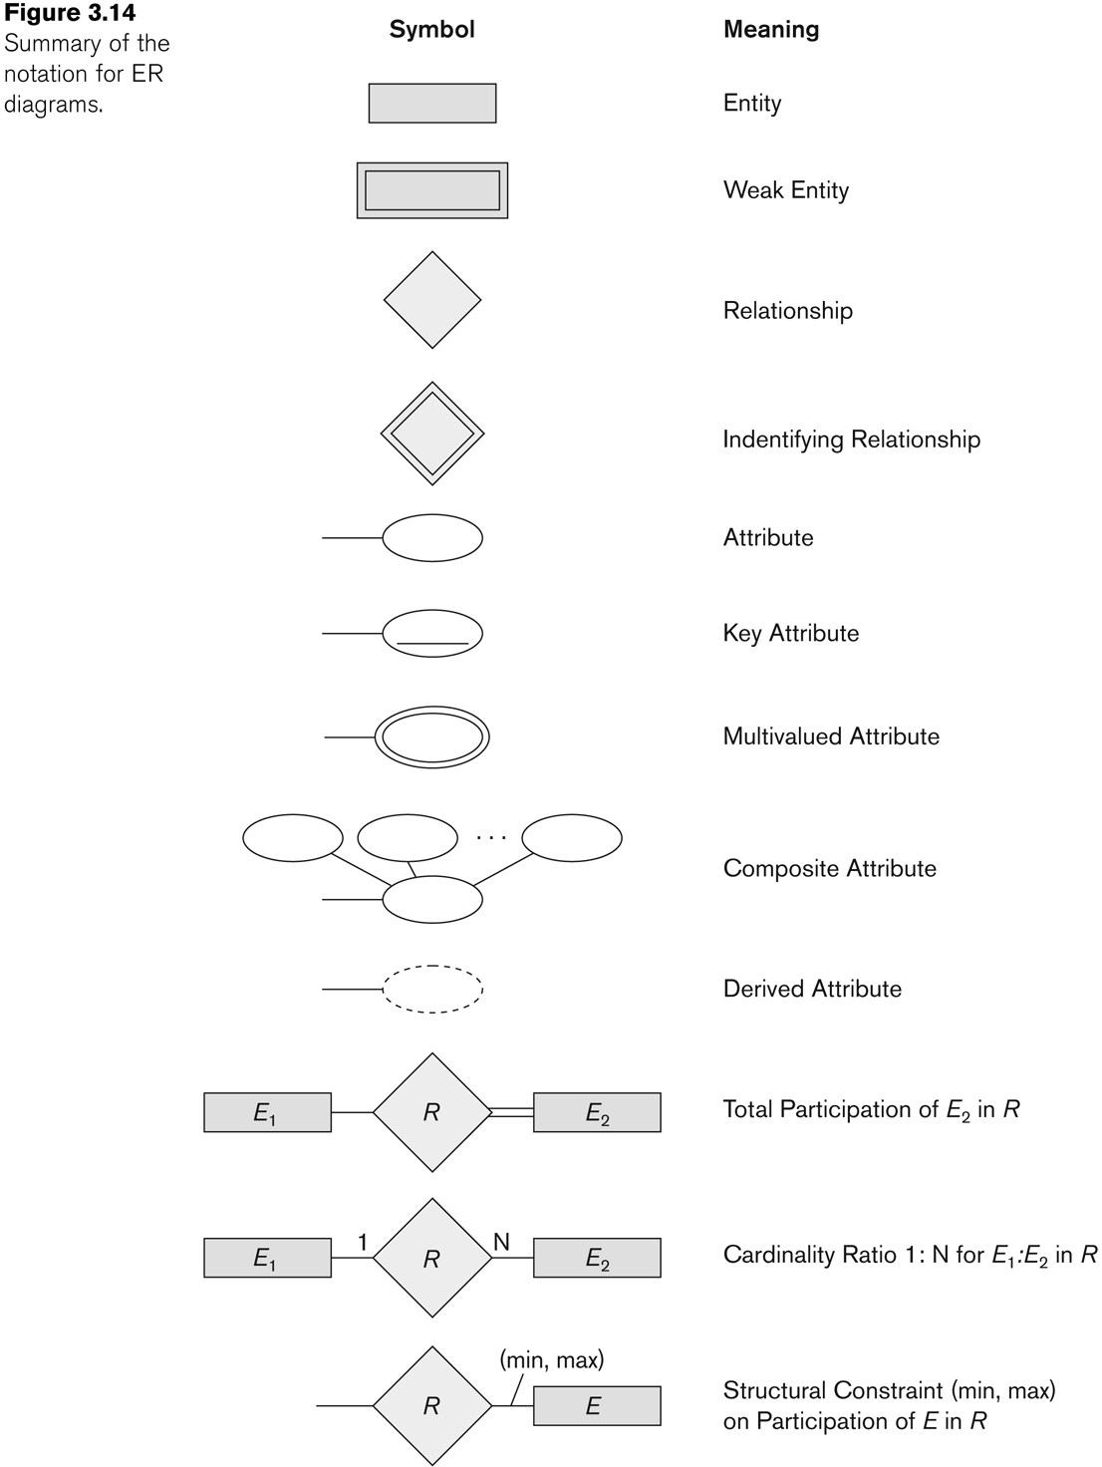
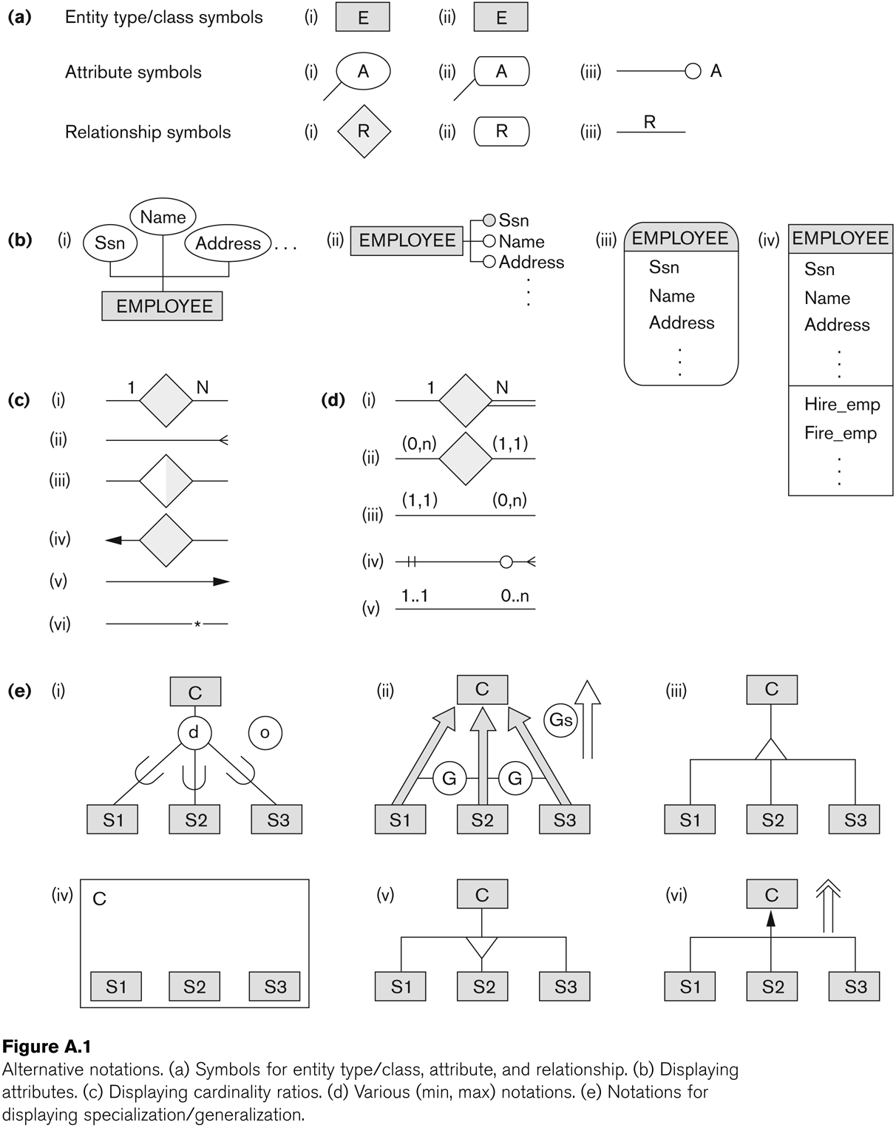
Categories /UNION TYPES

In some cases, we need to model a single superclass/subclass relationship with more than one superclass
Superclasses can represent different entity types
Such a subclass is called a category or UNION TYPE
Example: In a database for vehicle registration, a vehicle owner can be a PERSON, a BANK (holding a lien on a vehicle) or a COMPANY.

A category (UNION type) called OWNER is created to represent a subset of theunion of the three superclasses COMPANY, BANK, and PERSON.
A category member must exist in at least one of its superclasses.

Difference from shared subclass, which is a:
subset of the intersection of its superclasses
shared subclass member must exist in all of its superclasses

Formal Definitions of EER Model

Class C: A type of entity with a corresponding set of entities: could be entity type, subclass, superclass, or category
Note: The definition of relationship type in ER/EER should have 'entity type' replaced with 'class‘ to allow relationships among classes in general

Subclass S: A class whose type inherits all the attributes and relationship of a class C
Set of entities must always be a subset of the set of entities of the other class C
S ⊆ C ie. C is the superclass of S
A superclass/subclass relationship exists between S and C

Specialization Z: Z = {S1, S2,…, Sn} is a set of subclasses with the same superclass G; hence, G/Si is a superclass relationship for i = 1, …., n.
G is called a generalization of the subclasses {S1, S2,…, Sn}

Z is total if we always have: S1 ∪ S2 ∪ … ∪ Sn = G;
Otherwise, Z is partial.

Z is disjoint if we always have: Si ∩ Sj empty-set for i ≠ j;
Otherwise, Z is overlapping.

Subclass S of C is predicate defined if predicate (condition) p on attributes of
C is used to specify membership in S; that is, S = C[p], where C[p] is the set of entities in C that satisfy condition p

A subclass not defined by a predicate is called user-defined

Attribute-defined specialization: if a predicate A = ci (where A is an attribute of
G and ci is a constant value from the domain of A) is used to specify
membership in each subclass Si in Z

Note: If ci ≠ cj for i ≠ j, and A is single-valued, then the attribute-defined
specialization will be disjoint.

Category or UNION type T

A class that is a subset of the union of n defining superclasses D1, D2,…Dn, n>1: T ⊆ (D1 ∪ D2 ∪ … ∪ Dn)
Can have a predicate pi on the attributes of Di to specify entities of Di that are members of T.
If a predicate is specified on every Di: T = (D1[p1] ∪ D2[p2] ∪…∪ Dn[pn])

Benefits of Data Modeling
- Accurate Data Representation: It ensures whether the represented objects are accurate.
- Relationship between Database Objects: Ability to define a solid relationship between the tables, stored procedures, primary keys, and foreign keys.
- Clearer Scope: Data modeling is a form of documentation. The communication part is seamless here both within and across an organization.
- Identify Source of Data: Helps the recognition of sources of data to make the model more populated.
- Document Data Mapping: In the ETL process, it can be easy as the business allows document data mappings.
- Control of Data Redundancy: It can identify missing and redundant data
- Build Software Faster: Data Model used as a guide for writing SQL and SQL logics can be developed easily using Data Model.
- Data consistency
- Reduce Cost: Data Model catches errors early
Displaying constraints on higher-degree relationships
- The (min, max) constraints can be displayed on the edges – however, they do not fully describe the constraints
- Displaying a 1, M, or N indicates additional constraints
  - An M or N indicates no constraint
  - A 1 indicates that an entity can participate in at most one relationship instance that has a particular combination of the other participating entities
- In general, both (min, max) and 1, M, or N are needed to describe fully the constraints

Naming Convention
ENTITY
RELATIONSHIP
Attribute
role

Aggregation
An ER diagram is not capable of representing the relationship between an entity and a relationship which may be required in some scenarios. In those cases, a relationship with its corresponding entities is aggregated into a higher-level entity. Aggregation is an abstraction through which we can represent relationships as higher-level entity sets.
For Example, an Employee working on a project may require some machinery. So, REQUIRE relationship is needed between the relationship WORKS_FOR and entity MACHINERY. Using aggregation, WORKS_FOR relationship with its entities EMPLOYEE and PROJECT is aggregated into a single entity and relationship REQUIRE is created between the aggregated entity and MACHINERY.
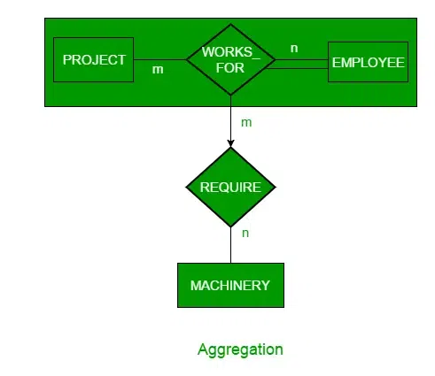
So basically relation between two entities is treated as a single entity.

Representing Aggregation Via Schema
To represent aggregation, create a schema containing the following things.
- the primary key to the aggregated relationship
- the primary key to the associated entity set
- descriptive attribute, if exists
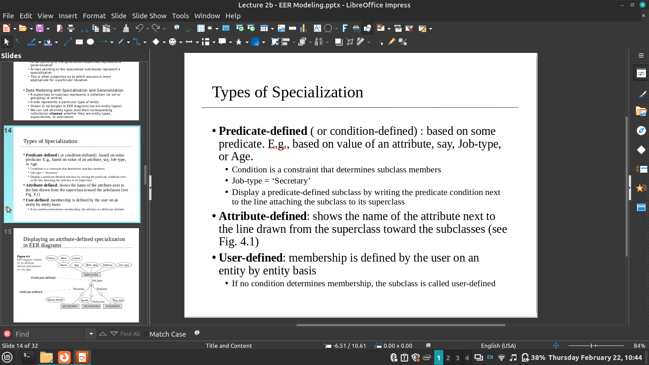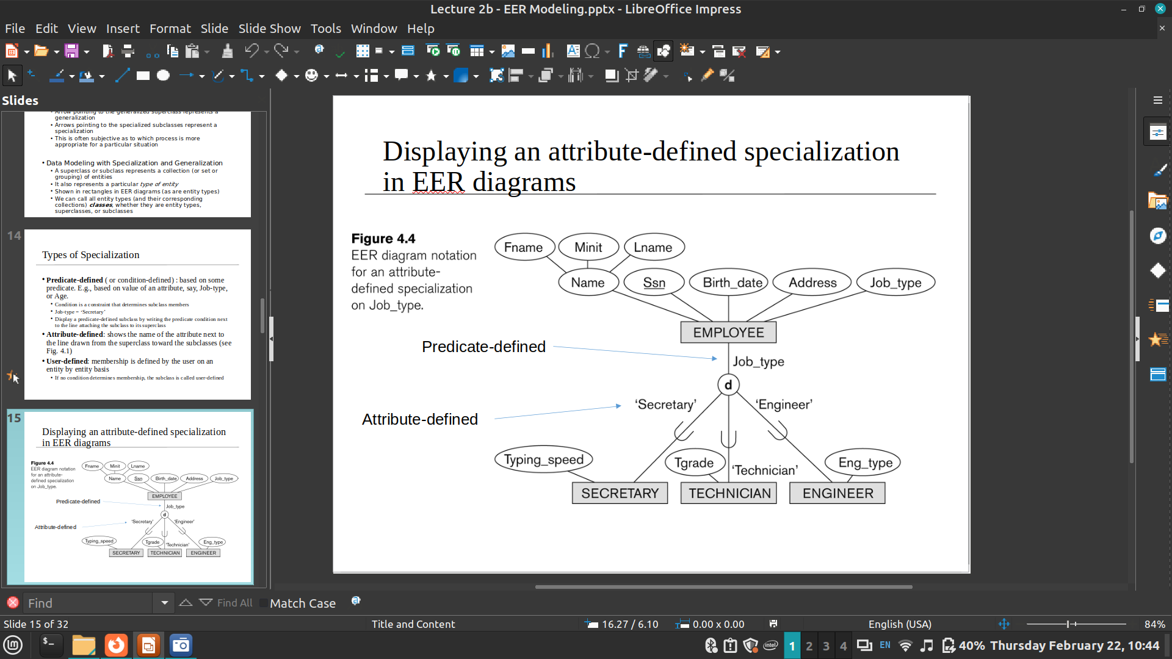
2.3
Advantages of Relational Database
High Security. Set the boundaries for accessing the data from a relational database that restricts unauthorized people to access the data.
Data Integrity. The integrity of data is maintained. The legitimacy validations and sturdy data entries make sure that all the data is stored with suitable arrangements and all the necessary relationships have been created among the data.
Flexibility. The data is updated every time you enter more data into it. Moreover, the repeated data is also deleted. The data is not crashed in the relational database no matter how big the length of the database is. You can add, delete or update the data in any of the fields easily. There is no boundary on the number of tables, columns, or rows in the relational database so you can store as much data as you want.
Data Accuracy. The primary key and foreign key are used in the relational database that keeps the data accurate. No repetitive data in the database. Not let unauthorized users make any change in your data. So, your data is protected from external users. You can allow the selected people to access your data or modify it.
Categorizing data. Database administrators can easily categorize and store data in a relational database that can then be queried and filtered to extract information for reports. Relational databases are also easy to extend and aren't reliant on physical organization. After the original database creation, a new data category can be added without having to modify the existing applications.
Accuracy. Data is stored just once, eliminating data deduplication in storage procedures.
Ease of use. Complex queries are easy for users to carry out with SQL, the main query language used with relational databases.
Collaboration. Multiple users can access the same database.
Security. Direct access to data in tables within an RDBMS can be limited to specific users.

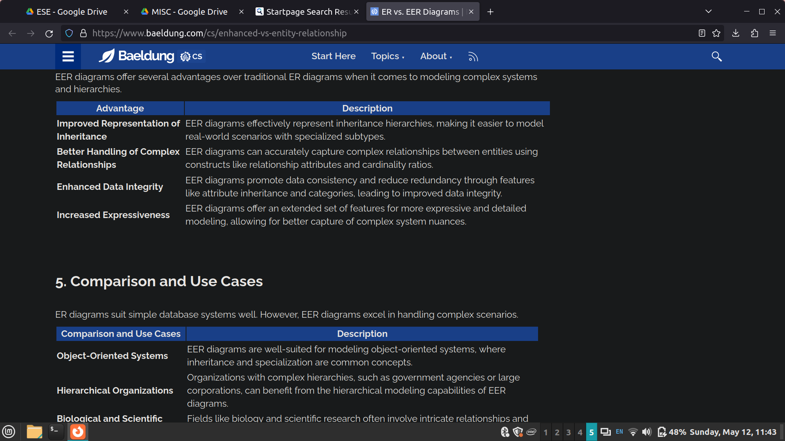
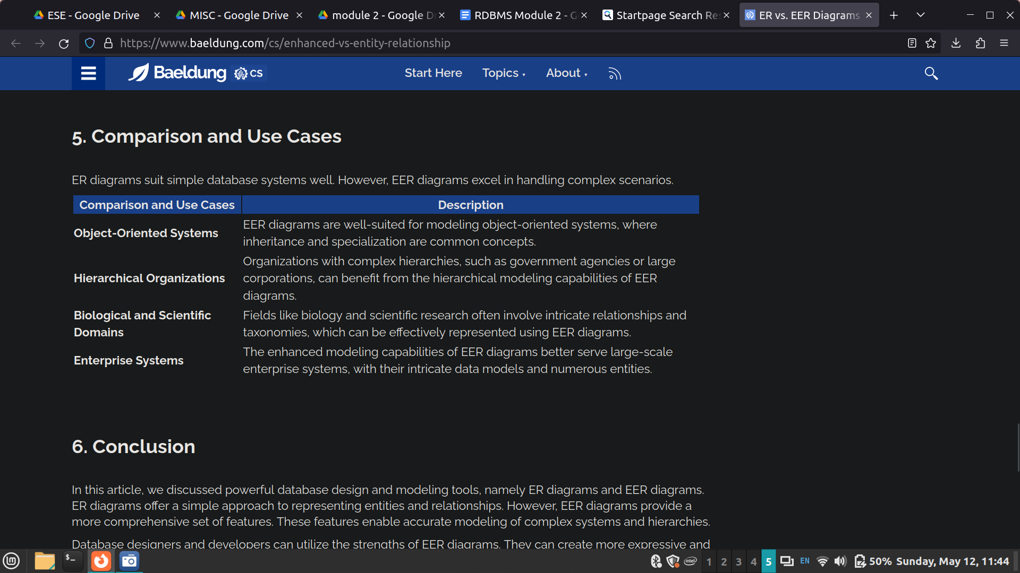

Difference Between DDL and DML
DDL | DML
It stands for Data Definition Language. | It stands for Data Manipulation Language.
It is used to create database schema and can be used to define some constraints as well. | It is used to add, retrieve, or update the data.
It basically defines the column (Attributes) of the table. | It adds or updates the row of the table. These rows are called tuples.
It doesn’t have any further classification. | It is further classified into Procedural and Non-Procedural DML.
Basic commands present in DDL are CREATE, DROP, RENAME, ALTER, etc. | BASIC commands present in DML are UPDATE, INSERT, MERGE etc.
DDL does not use WHERE clause in its statement. | While DML uses WHERE clause in its statement.
DDL is used to define the structure of a database. | DML is used to manipulate the data within the database.
DDL is used to create and modify database objects like tables, indexes, views, and constraints. | DML is used to perform operations on the data within those database objects.
DDL statements are typically executed less frequently than DML statement | DML statements are frequently executed to manipulate and query data.
DDL statements are typically executed by database administrators. | DML statements are typically executed by application developers or end-users.
DDL statements are not used to manipulate data directly. | DML statements are used to manipulate data directly.
The database’s contents are not altered by DDL commands. | DML commands alter the database’s contents.
Examples of DDL commands: CREATE TABLE, ALTER TABLE, DROP TABLE, TRUNCATE TABLE, and RENAME TABLE. | Examples of DML commands: SELECT, INSERT, UPDATE, DELETE, and MERGE.
